Linear measurement using a metric ruler

Measurements are important in our everyday life as well as in science class. Your height is charted as the doctor’s office to see if you are growing as you should. Land that is sold and bought must be accurately measured. Your parent’s car has an odometer that records the miles driven. In science class you may be instructed to cut something like wire or string to a prescribed length for a particular experiment. If you are doing a science fair project involving growth of plants, you need accurate measurements of the height of each plant in order to compare the treatments you are using. Just using taller or shorter is not enough.

In our everyday life in the US, we use what is called the English system of measurement. This includes units like inches, feet, yards and miles. In science and everywhere else in the world the International System of Units (SI) is used. This is also referred to as the metric system.

The basic unit for length in the metric system is the meter. Smaller and larger units are based on multiples of ten (10) and are named using prefixes. This chart shows the common ones we will be using.

Unit | Abbreviation | Relationship to a meter
Millimeter | mm | 1mm = 0.001 m  or  1 m = 1000 mm
Centimeter | cm | 1cm = 0.01 m  or  1 m = 1000 cm
Kilometer | km | 1km = 1000m  Or  1m = 0.001 km
The units on the rulers and meter sticks we will use are shown in this picture:
The units on the rulers and meter sticks we will use are shown in this picture:
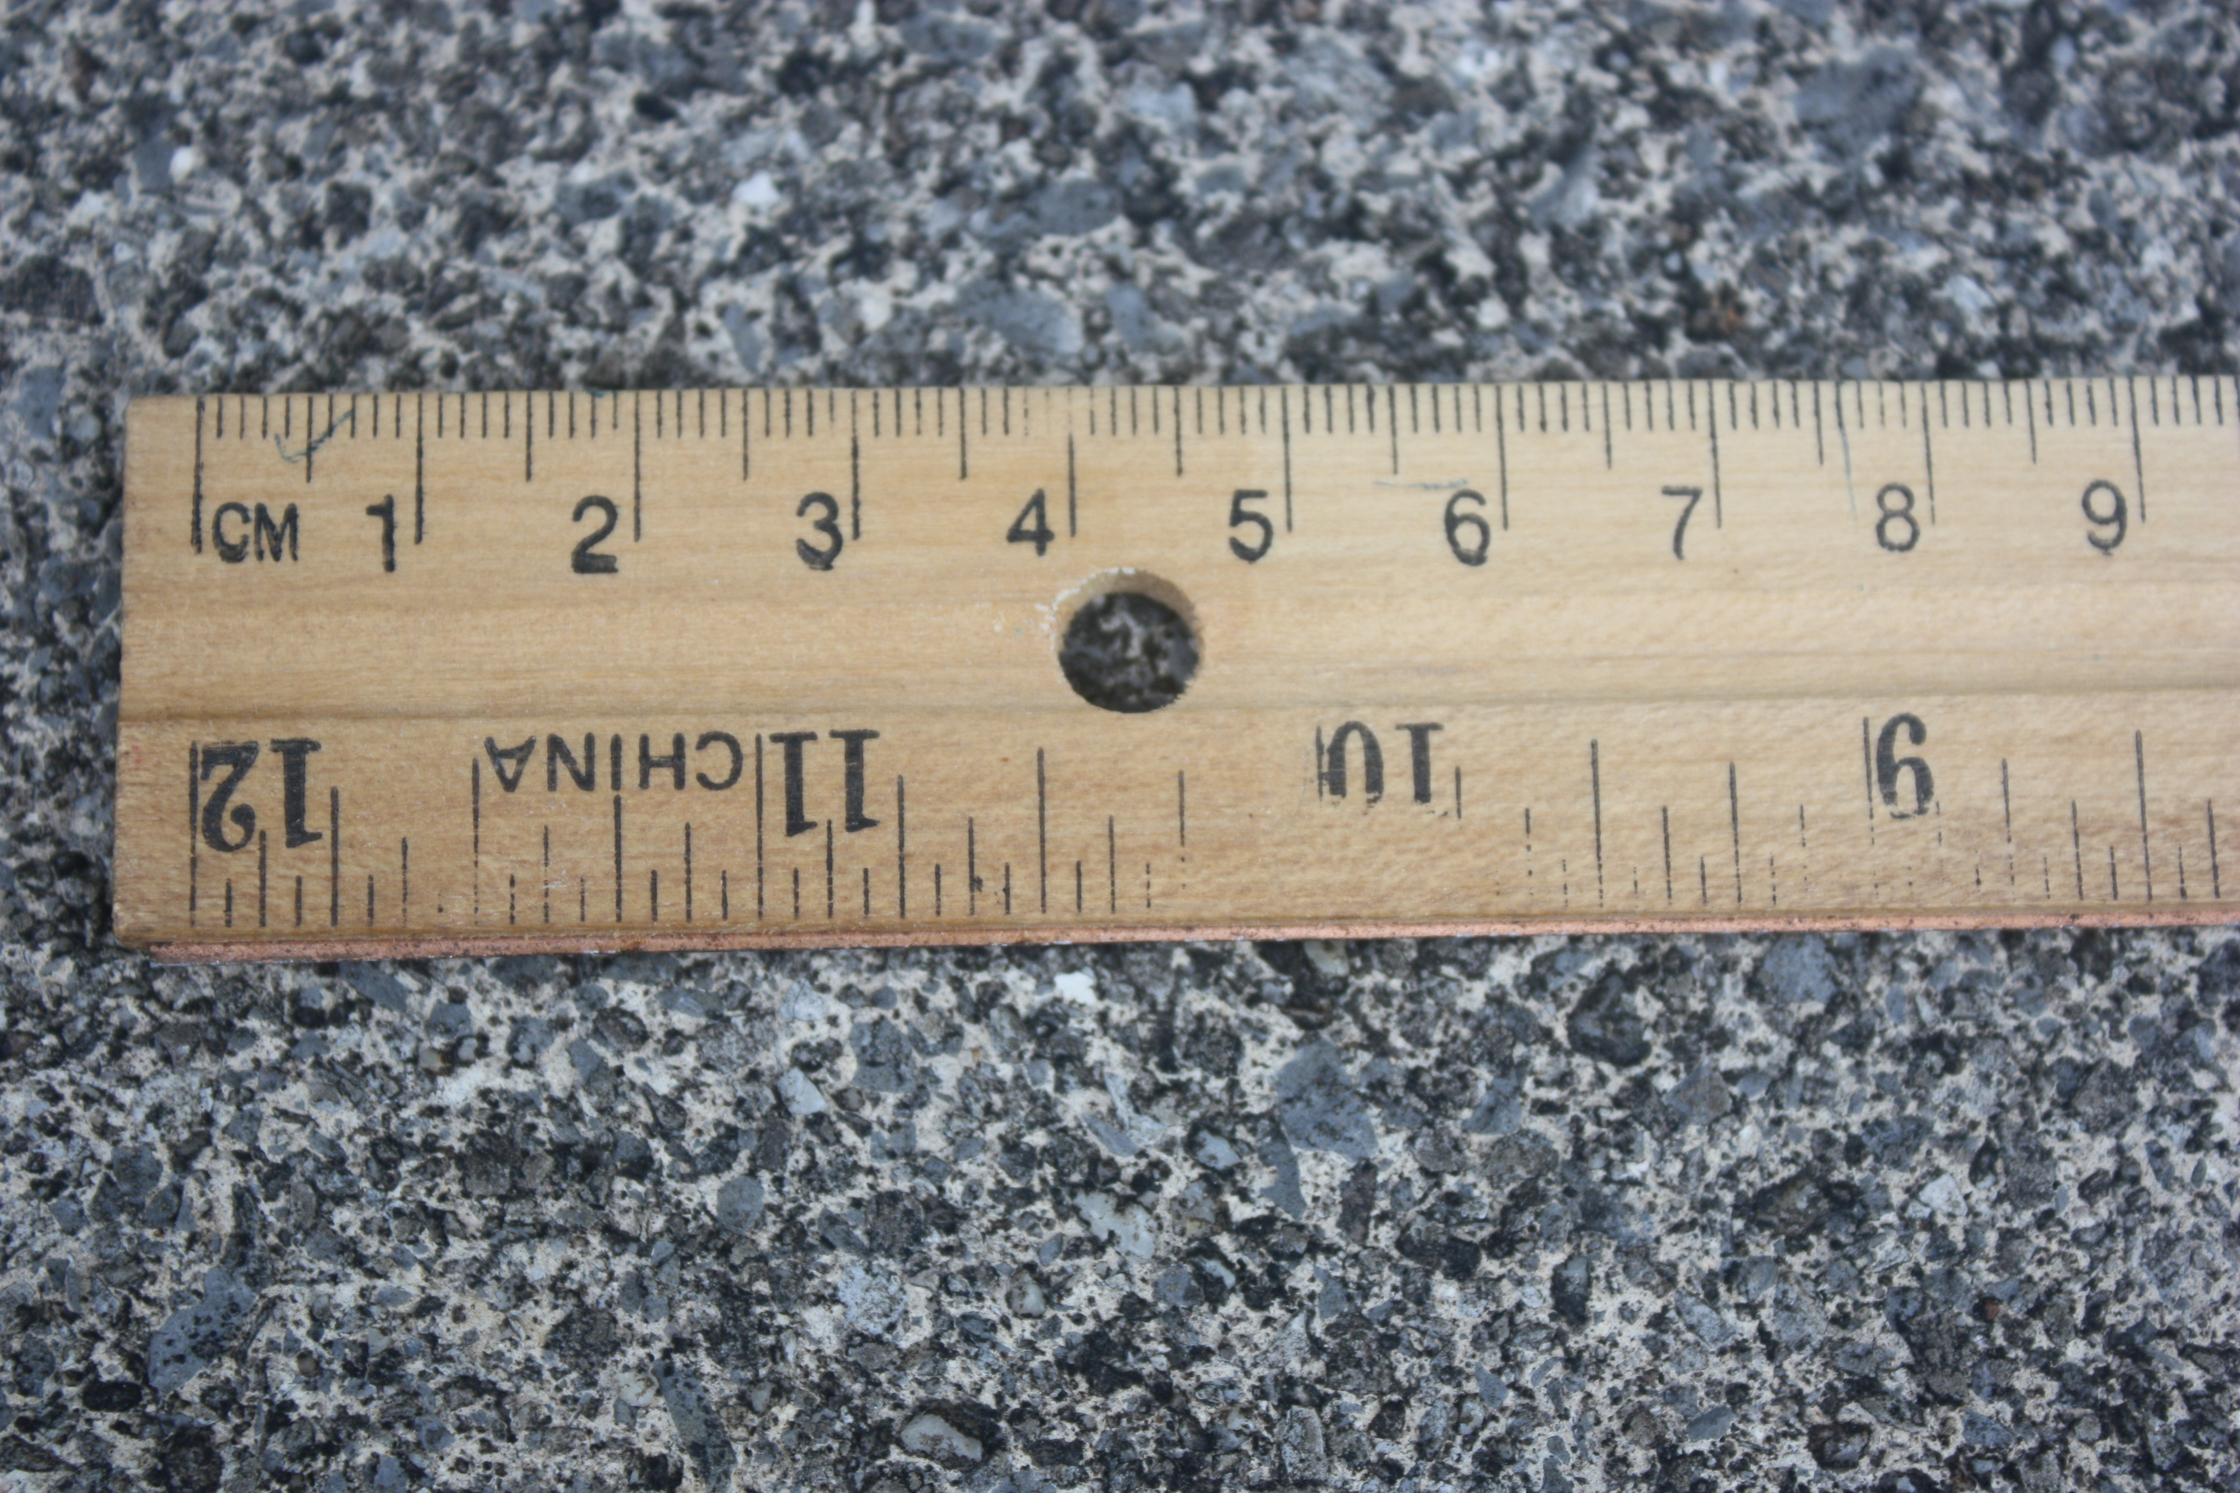
a cm a mm

Notice – the numbers on the rulers indicate centimeters.
Some general guidelines for making linear measurements are:
1. Choose the most suitable size unit for your measurement.
2. Note whether or not you ruler starts with 0 at the end or is it in a small bit from the end. Use it accordingly.
3. ALWAYS label your measurements on labs and worksheets with the correct units.
Practice reading a ruler. Fill in the blanks below the picture with the correct measurements. Be careful with units!

line 1
line 2
line 3
line 4

1. What is the length of line 1 in cm? ___________________________________________________
2. What is the length of line 1 in mm? ___________________________________________________
3. What is the length of line 2 in cm? ___________________________________________________
4. What is the length of line 2 in mm? ___________________________________________________
5. What is the length of line 3 in cm? ___________________________________________________
6. What is the length of line 3 in mm? ___________________________________________________
7. What is the length of line 4 in cm? ___________________________________________________
8. What is the length of line 4 in mm? ___________________________________________________
Name ________________________________________ Lab Using a metric ruler 6th grade

1. Use your metric ruler to measure each line in centimeters (cm) .

Line | Centimeters  (cm)
________________

________

_______________________________________________

__________________________________________

________

_____

__________________

2. Use your metric ruler to measure each line in millimeters (mm)

Line | millimeters  (mm)
________________

_______________________________

___

_______________________________________________

__________

__________________________________________

3. This map shows a path that Hurley takes to school each day. Measure the path in cm. Write down the length of each segment on your paper above or to the side of the segment.

a. Total length ________________________

b. If each cm = 0.25 km, how many km does Hurley walk? ________________

c. If each km = 0.621 miles, how many miles does Hurley walk?_________________

4. Using your ruler, fill in the following. Use cm or mm (whichever you think is appropriate) but be sure to put the units after your answer.

a. Length _____________ and width ________________ of an index card.

b. Length ______________ of an unsharpened pencil.

c. diameter _______________ and thickness _______________ of a penny.

d. Length __________________ and width ______________________ of this worksheet.

e. Height ________________ of a soda can.

5. How do you measure up?
In your group, divide into partners. Use the meter tape to measure the following on one person and record the results on that person’s paper. The measure the other person and record. Use centimeters and be sure to include units on your answer.
a. The distance around your head at your forehead.___________________________________
b. The distance around your neck __________________________________________
c. Your waist measure _________________________________________________
d. The distance around your wrist______________________________________________
e. Spread your hand out as much as you can on a piece of paper. Have your partner put a mark at the tip of your thumb and your pinkie finger. Measure the distance between the marks. This is your span.
_____________________________________________________
f. Stand up with your arms outstretched and parallel to the floor. Have your partner measure along your back from the tip of the longest finger on the left hand to the tip of the longest finger on the right hand. This is called a fathom. _____________________________________________
g. Measure your height.____________________________________________

A very famous scientist, Leonardo Da Vinci found the following to be true:
8 times your span = your fathom
your fathom = your height

Is this true for you? Fill in the blanks. If it is true, put yes it is true. If it is not true, tell by how much it is off.

8 X ___________ = ____________ = ___________
your span your fathom

True?______________________

___________________ = ___________________
your fathom your height

True?______________________________

