Progress Probe #1660778: 7th Grade Science TCAP Blitz Moderate Questions Week 6 (Grade 07 SC)
Teacher Key with Answers
Ques | Answer | Level | Skill | Subskill | Item #
1 | C | Moderate | Inquiry / Technology & Engineering | SPI 0707.Inq.1 Design Experiment [99103] | D85489
2 | C | Moderate | Inquiry / Technology & Engineering | SPI 0707.Inq.2 Select Experimental Procedures [99104] | D85194
3 | A | Moderate | Inquiry / Technology & Engineering | SPI 0707.Inq.3 Translate Data [99105] | U56103
4 | C | Moderate | Inquiry / Technology & Engineering | SPI 0707.Inq.3 Translate Data [99105] | U56135
5 | C | Moderate | Inquiry / Technology & Engineering | SPI 0707.T/E.1 Test Prototype [99108] | D103982
6 | D | Moderate | Inquiry / Technology & Engineering | SPI 0707.T/E.1 Test Prototype [99108] | D111577
7 | B | Moderate | Inquiry / Technology & Engineering | SPI 0707.T/E.3 Intented vs Unintended Consequences [99110] | D104260
8 | B | Moderate | Inquiry / Technology & Engineering | SPI 0707.T/E.4 Adaptive vs Assistive Bioengineering [99111] | U56275
9 | D | Moderate | Inquiry / Technology & Engineering | SPI 0707.T/E.4 Adaptive vs Assistive Bioengineering [99111] | U56289
10 | D | Moderate | LS: Cells/ Flow of Matter and Energy/ Heredity | SPI 0707.1.1 Cell Organelles [99112] | U56047
11 | B | Moderate | LS: Cells/ Flow of Matter and Energy/ Heredity | SPI 0707.1.2 Cells to Organ Systems [99113] | U55953
12 | A | Moderate | LS: Cells/ Flow of Matter and Energy/ Heredity | SPI 0707.1.2 Cells to Organ Systems [99113] | U55965
13 | A | Moderate | LS: Cells/ Flow of Matter and Energy/ Heredity | SPI 0707.1.3 Major Organ Systems [99114] | U56064
14 | B | Moderate | LS: Cells/ Flow of Matter and Energy/ Heredity | SPI 0707.1.3 Major Organ Systems [99114] | U56057
15 | D | Moderate | LS: Cells/ Flow of Matter and Energy/ Heredity | SPI 0707.1.4 Plant Cell Division [99115] | U56053
16 | A | Moderate | LS: Cells/ Flow of Matter and Energy/ Heredity | SPI 0707.1.4 Plant Cell Division [99115] | U56051
17 | B | Moderate | LS: Cells/ Flow of Matter and Energy/ Heredity | SPI 0707.3.1 Photosynthesis and Respiration [99117] | U55959
18 | B | Moderate | LS: Cells/ Flow of Matter and Energy/ Heredity | SPI 0707.3.2 Oxygen / Carbon Exchange [99118] | U56016
19 | D | Moderate | LS: Cells/ Flow of Matter and Energy/ Heredity | SPI 0707.3.2 Oxygen / Carbon Exchange [99118] | U56077
20 | A | Moderate | LS: Heredity | SPI 0707.4.1 Sexual vs Asexual Reproduction [99119] | U55927
21 | C | Moderate | LS: Heredity | SPI 0707.4.1 Sexual vs Asexual Reproduction [99119] | U56037
22 | C | Moderate | LS: Heredity | SPI 0707.4.2 Flowers and Reproduction [99120] | U55919
23 | C | Moderate | LS: Heredity | SPI 0707.4.3 Genes and Heredity [99121] | U56260
24 | B | Moderate | LS: Heredity | SPI 0707.4.3 Genes and Heredity [99121] | U56259
25 | B | Moderate | LS: Heredity | SPI 0707.4.4 Punnett Square [99122] | U56272
26 | D | Moderate | ES: The Earth | SPI 0707.7.1 Classify Minerals [99123] | U56029
27 | B | Moderate | ES: The Earth | SPI 0707.7.2 Label Rock Types [99124] | U56185
28 | D | Moderate | ES: The Earth | SPI 0707.7.2 Label Rock Types [99124] | D110783
29 | A | Moderate | ES: The Earth | SPI 0707.7.3 Rock Cycle [99125] | U56138
30 | D | Moderate | ES: The Earth | SPI 0707.7.3 Rock Cycle [99125] | U56205
31 | D | Moderate | ES: The Earth | SPI 0707.7.4 Earth's Layers [99126] | U56107
32 | B | Moderate | ES: The Earth | SPI 0707.7.5 Lithospheric Plates [99127] | U56173
33 | B | Moderate | ES: The Earth | SPI 0707.7.5 Lithospheric Plates [99127] | U56116
34 | A | Moderate | ES: The Earth | SPI 0707.7.6 Plate Movement [99128] | D55458
35 | D | Moderate | ES: The Earth | SPI 0707.7.7 Human Impact [99129] | U56238
36 | B | Moderate | ES: The Earth | SPI 0707.7.7 Human Impact [99129] | U56305
37 | A | Moderate | PS: Motion | SPI 0707.11.1 Simple Machines [99130] | U56220
38 | D | Moderate | PS: Motion | SPI 0707.11.2 Force and Work [99131] | U56215
39 | A | Moderate | PS: Motion | SPI 0707.11.2 Force and Work [99131] | U56216
40 | D | Moderate | PS: Motion | SPI 0707.11.3 Speed and Velocity [99132] | U56223
41 | A | Moderate | PS: Motion | SPI 0707.11.4 Newton's Laws [99133] | U56247
42 | B | Moderate | PS: Motion | SPI 0707.11.5 Waves [99134] | U55886
43 | A | Moderate | LS: Cells/ Flow of Matter and Energy/ Heredity | SPI 0707.3.1 Photosynthesis and Respiration [99117] | U56068
44 | C | Moderate | LS: Heredity | SPI 0707.4.2 Flowers and Reproduction [99120] | U55920
45 | A | Moderate | ES: The Earth | SPI 0707.7.1 Classify Minerals [99123] | U55987
46 | B | Moderate | ES: The Earth | SPI 0707.7.4 Earth's Layers [99126] | U56106
47 | B | Moderate | ES: The Earth | SPI 0707.7.5 Lithospheric Plates [99127] | U56114
48 | D | Moderate | ES: The Earth | SPI 0707.7.6 Plate Movement [99128] | D87722
49 | D | Moderate | PS: Motion | SPI 0707.11.2 Force and Work [99131] | U56085
50 | A | Moderate | PS: Motion | SPI 0707.11.4 Newton's Laws [99133] | U56090

Name: Date:
7th Grade Science TCAP Blitz Moderate Questions April 2- April 6 Week 6
Question 1 of 50
Richard calculates the time period of a pendulum by measuring the time taken by its bob to complete one swing. He obtains different results in air and in vacuum. To maintain openness in the experiment he should ______________.
 |  | A. | only record the readings obtained in air
 |  | B. | only record the readings obtained in vacuum
 |  | C. | record both readings and mention the experiment conditions
 |  | D. | calculate the average of values obtained from both the readings

Question 2 of 50
Mark and his younger brother are playing with firecrackers in his small backyard. This is _____________.
 |  | A. | a daring and funny but safe game
 |  | B. | safe game if played out in the open
 |  | C. | an unsafe game as it can cause burns
 |  | D. | only unsafe if played near wooden things

Question 3 of 50
A graph of the motion of a car is shown below.
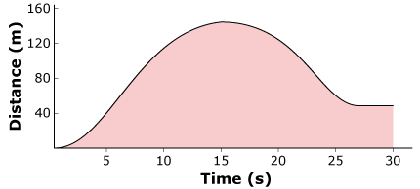
What is the speed of the car when it has traveled the distance of 40 meters?
 |  | A. | 8 m/s
 |  | B. | 8 m/s²
 |  | C. | 5 m/s
 |  | D. | 5m/s²

Question 4 of 50
Look at the pie chart.
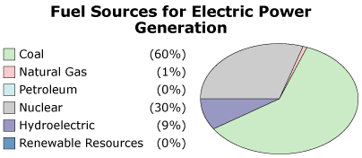
The pie chart shows the energy sources that were used to generate electricity in Tennessee in a given year. Based on the graph, what percent of electricity in Tennessee is generated using a fossil fuel?
 |  | A. | 30%
 |  | B. | 0%
 |  | C. | 60%
 |  | D. | 9%

Question 5 of 50
A child's toy is being developed that has openings which allow shapes to be inserted. Toddlers who will use the toy can get their hands stuck in openings from 4 to 6 centimeters in diameter. Also, children can choke on objects that are smaller than 4 centimeters in diameter.
Based on the information provided, what diameter would be approved for marketing?
 |  | A. | less than 4 centimeters
 |  | B. | approximately 5 centimeters
 |  | C. | larger than 6 centimeters
 |  | D. | anywhere between 4 and 6 centimeters

Question 6 of 50
Maxwell developed a new material he thinks would be good for lifejackets used while boating and swimming.
Which measurement would he find least useful in testing the material for use in lifejackets?
 |  | A. | absorbency of the material
 |  | B. | density of the material
 |  | C. | strength of the material
 |  | D. | transparency of the material

Question 7 of 50
New technology can improve productivitym which oftentimes makes products more affordable. Based on this information, which statement is most accurate?
 |  | A. | New technology is detrimental to the economy.
 |  | B. | New technology is beneficial to the economy.
 |  | C. | New technology has no effect on the economy.
 |  | D. | New technology has no effect on society.

Question 8 of 50
Diabetes is a growing concern in today's society. The hormone insulin is used in the treatment of diabetes. To manufacture large amounts of insulin, scientists insert the gene for insulin into plasmid DNA. This process is called gene ________
 |  | A. | cloning.
 |  | B. | splicing.
 |  | C. | sampling.
 |  | D. | combining.

Question 9 of 50
Researchers insert a segment of DNA from another species in place of an existing segment of DNA in a plant cell. What process are the researchers using?
 |  | A. | cross breeding
 |  | B. | natural selection
 |  | C. | cloning of a gene
 |  | D. | splicing of a gene

Question 10 of 50
A student observes a cell with many mitochondria. This cell is most likely what type of cell?
 |  | A. | a liver cell
 |  | B. | a skin cell
 |  | C. | a cheek cell
 |  | D. | a muscle cell

Question 11 of 50
Living organisms have different levels of organization. Which of the following lists the levels of organization from lowest to highest?
 |  | A. | organ system -> tissue -> organ -> cell
 |  | B. | cell -> tissue -> organ -> organ system
 |  | C. | organ system -> organ -> tissue -> cell
 |  | D. | cell -> organ -> tissue -> organ system

Question 12 of 50
Which of the following do birds use to get the oxygen they need from the air?
 |  | A. | lungs
 |  | B. | kidneys
 |  | C. | stomach
 |  | D. | vocal chords

Question 13 of 50
Earthworms need oxygen from the air. Which of these allows oxygen to enter their body?
 |  | A. | the skin
 |  | B. | the heart
 |  | C. | the kidneys
 |  | D. | the intestine

Question 14 of 50
Which body system has the major responsibility for getting rid of solid waste?
 |  | A. | the respiratory system
 |  | B. | the digestive system
 |  | C. | the excretory system
 |  | D. | the endocrine system

Question 15 of 50
John has drawn pictures of three of the four stages of mitosis.
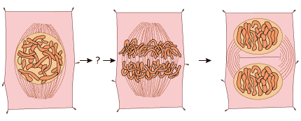
Which of these pictures is the missing stage?
 |  | A. | 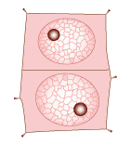
 |  | B. | 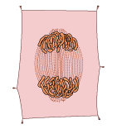
 |  | C. | 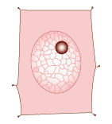
 |  | D. | 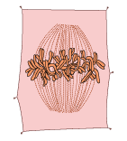

Question 16 of 50
The picture shows a stage of mitosis.
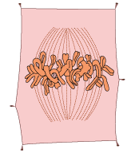
Which of these is the next stage of mitosis?
 |  | A. | 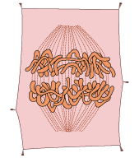
 |  | B. | 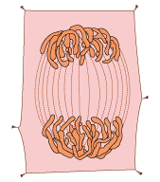
 |  | C. | 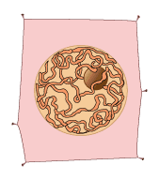
 |  | D. | 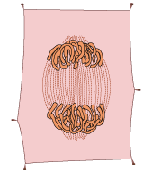

Question 17 of 50
Which of the following is needed by plants to make food?
 |  | A. | sugar
 |  | B. | light
 |  | C. | oxygen
 |  | D. | nitrogen

Question 18 of 50
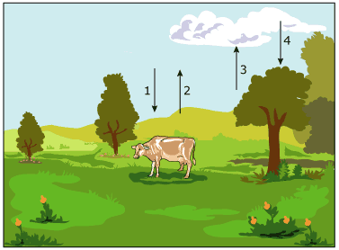
At which point is oxygen taken in for breathing by organisms?
 |  | A. | 1
 |  | B. | 2
 |  | C. | 3
 |  | D. | 4

Question 19 of 50
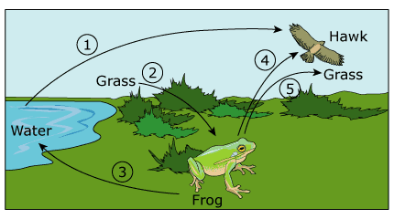
Which arrow on the diagram above shows carbon dioxide being used by a producer?
 |  | A. | 2
 |  | B. | 3
 |  | C. | 4
 |  | D. | 5

Question 20 of 50
Zebras use time and energy in finding and attracting mates. In zebras, this disadvantage is partly offset by
 |  | A. | an increase in trait variability
 |  | B. | an increase in tissue formation
 |  | C. | a faster rate of cell reproduction
 |  | D. | a large number of cell compartments

Question 21 of 50
Which is an example of asexual reproduction?
 |  | A. | Flowers that are pollinated by bumblebees to produce new flowers.
 |  | B. | Animals that receive a combination of genes from its parents.
 |  | C. | Animals that are identical to its parent.
 |  | D. | Plants that require seeds and spores to produce new plants.

Question 22 of 50
What part of a flower produces pollen grains?
 |  | A. | stigma
 |  | B. | petal
 |  | C. | anther
 |  | D. | pistil

Question 23 of 50
White-tailed deer usually have brown and white coats. The pigments that produce hair color are absent in an albino white-tailed deer. Albinism appears in about 1 in 30,000 deer.
Which statement best explains why two albino parent deer will always produce albino offspring?
 |  | A. | White hair color is a dominant trait.
 |  | B. | Brown hair color is only expressed in heterozygotes.
 |  | C. | Each parent has two recessive alleles for albinism.
 |  | D. | Each parent carries a dominant allele for albinism.

Question 24 of 50
The Punnent square below shows a cross between two heterozygous pea plants that results in 3/4 tall and 1/4 short plants.
 | ? | ?
? | tall | tall
? | tall | short
What is the genotype of the parents in this cross? (tall (T) is dominant short (t) is recessive.)
 |  | A. | TT X tt
 |  | B. | Tt X Tt
 |  | C. | Tt X tt
 |  | D. | Tt X TT

Question 25 of 50
Excessive exposure to radiation or specific chemicals can cause a change in cellular DNA. This change is known as ________
 |  | A. | mitosis.
 |  | B. | mutation.
 |  | C. | expression.
 |  | D. | assortment.

Question 26 of 50
Which best describes the difference between the molecules of an ice cube and molecules of liquid water?
 |  | A. | The molecules of an ice cube are larger than those of liquid water.
 |  | B. | The molecules of liquid water move much slower than those of an ice cube.
 |  | C. | The molecules of liquid water have stronger bonds than those of an ice cube.
 |  | D. | The molecules of an ice cube are arranged more regularly than those of liquid water.

Question 27 of 50
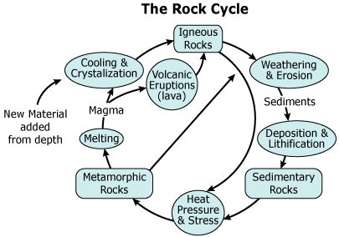
Which process results directly in igneous rock formation?
 |  | A. | melting
 |  | B. | cooling
 |  | C. | erosion
 |  | D. | deposition

Question 28 of 50
The diagram below shows a cross section of a volcanic island.
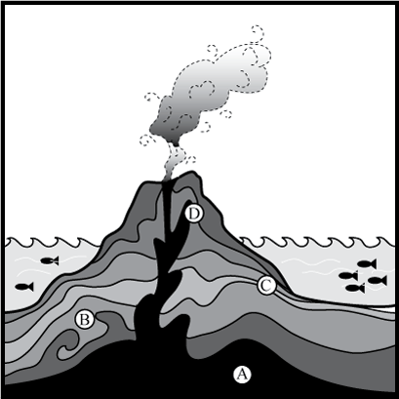
The place labeled with the letter A contains molten rock that can can erupt through places where Earth's crust is thin. This molten rock hardens as it cools; if enough of it builds up on the ocean floor it will eventually form an island.
What is the name of the place labeled with the letter A in the diagram?
 |  | A. | outer core
 |  | B. | thermosphere
 |  | C. | inner core
 |  | D. | mantle

Question 29 of 50
Brian examined rocks from a local riverbed. Many of the rocks he observed were rounded. Which of the following processes most shaped the rounded rocks?
 |  | A. | mechanical friction
 |  | B. | chemical erosion
 |  | C. | metamorphosis
 |  | D. | cementation

Question 30 of 50
Which process causes rocks to break down?
 |  | A. | sedimentation
 |  | B. | calcification
 |  | C. | metamorphosis
 |  | D. | weathering

Question 31 of 50
The diagram below shows the layers of Earth.
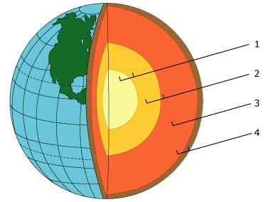
Which of the following sections is the lithosphere?
 |  | A. | 1
 |  | B. | 2
 |  | C. | 3
 |  | D. | 4

Question 32 of 50
Which of these processes occurs where continental plates drift toward oceanic plates?
 |  | A. | oceanic plate sedimentation
 |  | B. | oceanic plate subduction
 |  | C. | continental plate divergence
 |  | D. | continental plate collision

Question 33 of 50
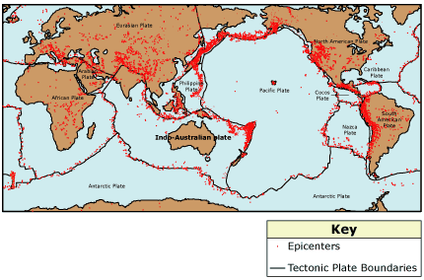
Why are earthquakes more common near the boundaries of tectonic plates?
 |  | A. | Earthquakes cause tectonic plates to form.
 |  | B. | Earthquakes are caused by the movement of tectonic plates.
 |  | C. | Earthquakes cause tectonic plates to subduct.
 |  | D. | Earthquakes are caused by the formation of tectonic plates.

Question 34 of 50
One of the long term effects of volcanoes is the release of huge amounts of ash into the atmosphere. On paper describe other effects of releasing tons of ash into the atmosphere.
The climate is a well balanced system that works in certain patterns. If these patterns are altered there can be a negative effect on the climate. A volcanic eruption might cause which negative side effect on climate?
 |  | A. | increased temperature due to release of carbon dioxide into the air
 |  | B. | increased precipitation levels due to disturbances in the air
 |  | C. | loss of habitat
 |  | D. | decreased temperature due to release of oxygen into the atmosphere

Question 35 of 50
Look at the graph.
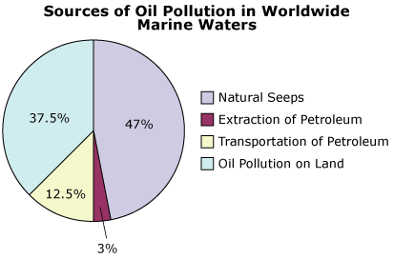
Oil pollution is becoming a major concern of environmentalists today. Which of the following is the largest non-natural source of oil pollution in marine waters?
 |  | A. | natural seeps
 |  | B. | extraction of petroleum
 |  | C. | transportation of petroleum
 |  | D. | oil pollution on land

Question 36 of 50
The students make a list of resources on a farm. Which of these resources is non-renewable?
 |  | A. | the fertile soil used to grow the grass
 |  | B. | the diesel fuel used to power the tractor
 |  | C. | the direct sunlight used to dry the horse's hay
 |  | D. | the organic cotton used to make the farmer's shirt

Question 37 of 50
Which of these tools would best hold two pieces of wood tightly together?
 |  | A. | screw
 |  | B. | lever
 |  | C. | pulley
 |  | D. | wheel

Question 38 of 50
Which of these objects requires the most force to accelerate from a standstill to a 1 m/s speed?
 |  | A. | 10 kg steel ball
 |  | B. | 3 kg clay flowerpot
 |  | C. | 5 kg block of ice
 |  | D. | 12 kg wooden log

Question 39 of 50
A player pitches a baseball at a speed of 90 mph. Which of these would cause the baseball to accelerate faster with the same throwing force?
 |  | A. | The baseball has less mass.
 |  | B. | The baseball travels farther.
 |  | C. | The baseball is thrown at a higher target.
 |  | D. | The baseball drifts in a crosswind.

Question 40 of 50
A car traveled 50 miles from Gold City to Silver City at the rate of 50 mph. About how long did this take?
 |  | A. | 30 minutes
 |  | B. | 45 minutes
 |  | C. | 50 minutes
 |  | D. | 60 minutes

Question 41 of 50
Which of the following forces opposes the movement of a hockey puck as it slides across the ice?
 |  | A. | friction
 |  | B. | centrifugal force
 |  | C. | centripetal force
 |  | D. | momentum

Question 42 of 50
The diagram shows a wave.
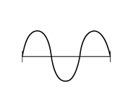
Which of the following shows the wave with the highest frequency?
 |  | A. | 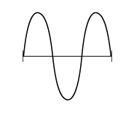
 |  | B. | 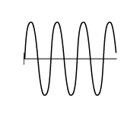
 |  | C. | 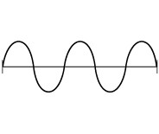
 |  | D. | 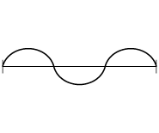

Question 43 of 50
Plants can live in a sealed container because they are able to photosynthesize and respire. Which of these is a product of photosynthesis that plants must have for respiration?
 |  | A. | oxygen
 |  | B. | starches
 |  | C. | proteins
 |  | D. | carbon dioxide

Question 44 of 50
Ovules are enclosed in the ovary and after fertilization they become ________
 |  | A. | fruit.
 |  | B. | cotyledon.
 |  | C. | seeds.
 |  | D. | pollen grains.

Question 45 of 50
Which of the following best represents an element?
 |  | A. | 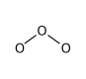
 |  | B. | 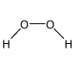
 |  | C. | 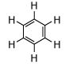
 |  | D. | 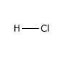

Question 46 of 50
Look at the cross section of Earth.
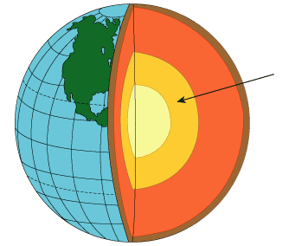
What is the name of the layer marked by the arrow?
 |  | A. | crust
 |  | B. | outer core
 |  | C. | mantle
 |  | D. | inner core

Question 47 of 50
All of the following provide evidence for continental drift except ________
 |  | A. | the shape of the continents
 |  | B. | seismic studies of the Earth’s interior
 |  | C. | similarities in fossil specimens found on different continents
 |  | D. | evidence of glacial movement

Question 48 of 50
The Grand Canyon has been formed due to erosion by the Colorado River. Rocks found in the Grand Canyon date back to almost 17 million years. What can be concluded from this?
 |  | A. | Erosion by the Colorado River is taking place only at present.
 |  | B. | Erosion by the Colorado River was taking place only in the past.
 |  | C. | Erosion has taken place sometimes while it was absent during other times.
 |  | D. | Erosion has been a continuous process throughout the history of the canyon.

Question 49 of 50
If a moving object is not affected by an unbalanced force, the object will ________
 |  | A. | change direction and slow down.
 |  | B. | not change direction, but it will slow down.
 |  | C. | change direction but will continue moving at the same speed.
 |  | D. | not change direction and continue moving at the same speed.

Question 50 of 50
Which of the following conditions is necessary for a moving object to accelerate?
 |  | A. | The forces acting on an object are unbalanced.
 |  | B. | The forces acting on an object are balanced.
 |  | C. | A force is equal to the mass of the object.
 |  | D. | A force converts friction into energy.

