Progress Probe #1660402: 6th Grade Science TCAP Blitz Feb. 25-March 1Week 1 (Grade 06 SC)
Teacher Key with Answers
Ques | Answer | Level | Skill | Subskill | Item #
1 | D | Moderate | Inquiry / Technology & Engineering | SPI 0607.Inq.1 Design Experiment [99073] | D100996
2 | D | Moderate | Inquiry / Technology & Engineering | SPI 0607.Inq.2 Select Experimental Procedures [99074] | D102671
3 | B | Moderate | Inquiry / Technology & Engineering | SPI 0607.Inq.3 Translate Data [99075] | D110785
4 | B | Moderate | Inquiry / Technology & Engineering | SPI 0607.Inq.4 Cause and Effect [99076] | D100920
5 | B | Moderate | Inquiry / Technology & Engineering | SPI 0607.Inq.5 Experimental Error [99077] | D101080
6 | A | Moderate | Inquiry / Technology & Engineering | SPI 0607.T/E.1 Test Prototype [99078] | D110356
7 | C | Moderate | Inquiry / Technology & Engineering | SPI 0607.T/E.2 Evaluate Protocol [99079] | D101293
8 | C | Moderate | Inquiry / Technology & Engineering | SPI 0607.T/E.3 Intented vs Unintended Consequences [99080] | D101299
9 | A | Moderate | Inquiry / Technology & Engineering | SPI 0607.T/E.4 Adaptive vs Assistive Bioengineering [99081] | D110359

Name: Date:
6th Grade Science TCAP Blitz Feb. 27-March 2 Week 1
Question 1 of 9
Which of the following would be considered a poor method of scientific investigation?
 |  | A. | using a control in the investigation
 |  | B. | forming a hypothesis before beginning the investigation
 |  | C. | re-doing the same investigation to verify your results
 |  | D. | copying the data from another person's investigation if yours looks wrong

Question 2 of 9
When using the Internet, which of the following is considered safe to do?
 |  | A. | Enter your name and address in a contest on a "pop-up."
 |  | B. | Send your picture to someone you are chatting with.
 |  | C. | Arrange to meet online friends so they are no longer strangers to you.
 |  | D. | Delete any files or documents from unknown senders.

Question 3 of 9
Chelsea recorded the average temperatures in Nashville, Tennessee every day for one week. Her data are shown below:
Monday: 68 °F
Tuesday: 71 °F
Wednesday: 78 °F
Thursday: 80 °F
Friday: 82 °F
Saturday: 81 °F
Sunday: 81 °F
Which line graph show the trend of the temperatures for the week?
 |  | A. | 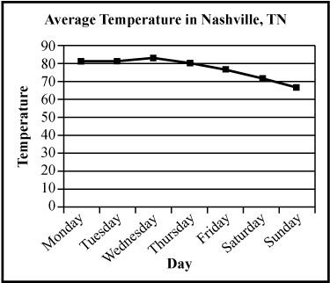
 |  | B. | 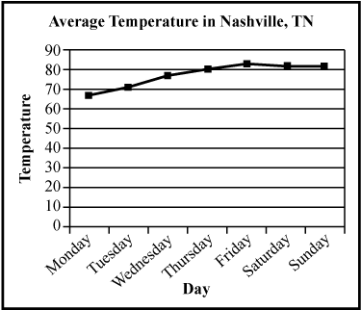
 |  | C. | 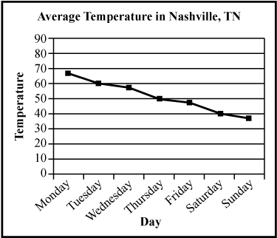
 |  | D. | 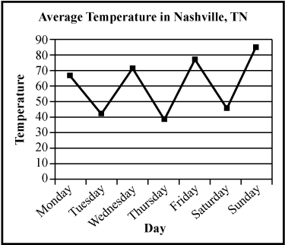

Question 4 of 9
Salamanders are sensitive species that can not live in highly polluted streams. Happy Creek once was home to many salamanders, but none have been seen in the past year. Make a conclusion based on this information.
 |  | A. | Happy Creek's water quality has improved.
 |  | B. | Happy Creek's water quality has become worse.
 |  | C. | Happy Creek's water quality has stayed the same.
 |  | D. | Happy Creek is and always has been the best habitat for salamanders.

Question 5 of 9
In order for a scientific experiment to be a fair test, there must only be one _____________.
 |  | A. | controlled variable
 |  | B. | independent variable
 |  | C. | examination
 |  | D. | measurement

Question 6 of 9
Ms. Samuels gave her science class an assignment to design a compound machine that can perform a task, but that does not use electricity or fuel. Once students produced several designs, they would work in pairs to develop a working prototype.
Marta and Sibyl chose to make a sewing machine that would use a foot pedal to power the machine.
Marta and Sybil had to take their prototype sewing machine apart several times to trouble shoot problems. The machine was made of metal and held together with small screws, nuts and bolts.
Which tool would not help them take the machine apart and put it back together?
 |  | A. | hammer
 |  | B. | pliers
 |  | C. | screwdriver
 |  | D. | wrench

Question 7 of 9
Which of the following is the best reasoning for why scientific theories change throughout time?
 |  | A. | all of earth's processes change
 |  | B. | humans have larger brains
 |  | C. | improvements are made in tools and technology
 |  | D. | the invention of television

Question 8 of 9
Nuclear medicine began with what discovery?
 |  | A. | lightning
 |  | B. | radio waves
 |  | C. | x-rays
 |  | D. | pharmaceuticals

Question 9 of 9
Biologists are working to develop a strain of bacteria that can decompose petroleum in salt water habitats. They started with a strain of bacteria that lives in fresh water and has been observed to break down vegetable oils.
Which word best characterizes the bio-engineered product these biologists hope to produce?
 |  | A. | adaptive
 |  | B. | aggressive
 |  | C. | assistive
 |  | D. | attractive

Copyright © Discovery Education Assessment 2012. Proprietary Information. All rights reserved.
Discovery Education Page

